Starting with Bold for Delphi/Bold for C++
Part 1: Introducing the basics

Anthony Richardson - anthony@viewpointsa.com
1 August 2002, Revision 1.1

All trademarks are properties of their respective holders. All intellectual property claims are respected. The publication is copyright 2002 by Anthony Richardson. Anthony Richardson grants BoldSoft MDE AB a royalty-free non-exclusive license to distribute this publication worldwide.

I would like to acknowledge the assistance of BoldSoft MDE AB in the creation of these articles. Especially the assistance of Jesper Hogstrom, Jonas Hogstrom and Dan Nygren, without their support this project would not have been possible.
Contents
Starting with Bold for Delphi/Bold for C++ 1
Getting Started 3
Introduction 3
Contacting Anthony Richardson 3
Contacting BoldSoft 3
Model Based Development 4
Introduction 4
What is modeling? 4
The Example Application Class Model 6
Building the Application 8
Introduction 8
Groundwork 8
Models, Handles and Persistence 8
Basic configuration Changes 9
Building the Model 11
Adding a User Interface 18
Running The Application 21
Entering Test Data 21
Delphi Data-aware and Bold-aware Comparison 22
Default Object Editor Forms 22
Summary 25
Future 25
Appendix A: Source Code 26
Instructions 26
ContactManager.dpr 27
MainForm.pas 28
MainForm.dfm 29
BusinessLayer.pas 33
BusinessLayer.dfm 34

Getting Started

Introduction
‘Starting with Bold for Delphi’ is a series of articles design to provide an introduction to the Bold for Delphi product and effective techniques for applying the Bold framework in the development of real world applications.

These articles are designed as an introduction. The Bold for Delphi product contains many components and is comprised of 1765 classes spread across over 665 units. The product contains many sub frameworks within these classes to support advanced development techniques and the application of industry best practices in the form of patterns, interfaces and modeling.

The design of Bold for Delphi is carefully layered to enable rapid adoption of core techniques with the gradual adoption of the more complex or sophisticated methods as required. These articles are designed to facilitate the transition from traditional programming to the core Bold for Delphi techniques.

Contacting Anthony Richardson
All feedback on this article is welcome:

Email: anthony@viewpointsa.com

Web: http://www.viewpointsa.com

Contacting BoldSoft
Getting help with using Bold for Delphi is available from BoldSoft.

Email: support@boldsoft.com

Web: http://www.boldsoft.com

Model Based Development

Introduction
The term model based development is used often when describing the Bold for Delphi product. The term refers to the process of developing your application directly from the class model, rather than traditional process of transforming an entity-relationship model into a table structure and then coding your application to the table structure.

Bold for Delphi applies Object Oriented flexibility and design to the persistence layer of your application making design easier. It is worth spending time on this upfront because this is a huge part of the productivity enhancement you will experience when using the Bold for Delphi architecture.

What is modeling?
A model is a description or view of something. Like a model aircraft is a miniature representation of a real aircraft, a software model is a representation of the domain that the software is designed for. It is possible to generate many different models for a particular software project. Popular software engineering methodologies describe models and activities at various stages of the software development lifecycle which aid in the understanding of the problem domain. Models also simplify communication between developers, users and other stakeholders. By creating the various types of models you can describe a complex software system in a series progressively more detailed set of views into the problem domain.

Traditional Entity-Relationship Modeling
Entity Relationship Modeling (ER Modeling) has traditionally been the method used to describe the business data for an application, the term data modeling is also used. Generally these models are restricted to portraying a static view of the data within a problem domain and fail to recognize the operations and interactions between entities.
After the completion of the ER model a database schema is developed. During this process the types of relationships portrayed in the ER model are transformed into a format that is suitable for the database. Certain types of relationships will result in extra tables being generated and the introduction of various primary and secondary keys. Where data may have been originally design with concepts like inheritance relationships, these models are ‘flattened’ to allow for the design to fit within the constraints of a relational database. This will tend to result in the loss of information from the model, not in terms of the information stored, but in the implied relationships and business rules of a fully normalized ER model.

Class Modeling
Class Modeling is a modern version of ER modeling that expands on the benefits of diagramming domain entities and their relationships and includes the interaction between those classes. Where ER Modeling is only modeling the data as required to be saved, the class model includes all domain entities and the operations performed by those entities. This allows for a much more accurate view of the business problem domain. By using class modeling and the various diagramming techniques available it is easier to build the correct software architecture earlier. The classes in a class model may also be referred to as business objects.

Business Objects
The term business object is used in many different ways and means different things to different people. Other terms used for business objects are domain objects and business classes. The process of storing and retrieving these business objects is often referred to as object persistence or object relational mapping. Frameworks that support the use of business objects are often referred to as object persistence frameworks.

Using business objects is the application of object-oriented techniques beyond coding and infrastructure into the realm of the real-world items (objects) being used by your software. An example of a using business objects is part of this article.

Unified Modeling Language (UML)
From the UML website, www.uml.org :

“The Unified Modeling Language (UML) is a language for specifying, visualizing, constructing, and documenting the artifacts of software systems, as well as for business modeling and other non-software systems. The UML represents a collection of best engineering practices that have proven successful in the modeling of large and complex systems.

The UML was developed by Rational Software and its partners. It is the successor to the modeling languages found in the Booch, OOSE/Jacobson, OMT and other methods. Many companies are incorporating the UML as a standard into their development processes and products, which cover disciplines such as business modeling, requirements management, analysis & design, programming and testing.”

UML is critical for the use of Bold for Delphi. The Bold for Delphi product includes its own UML modeling tool. Learning UML is easy and applying the full range of UML modeling techniques is a rewarding process.

The Example Application Class Model
This tutorial will build a simple address book application. The basic needs for our application are:
- Store contact information for people.
- Store contact information for companies.
- Allow for people to be associated with a company.

We are going to implement the following UML model for our address book application:

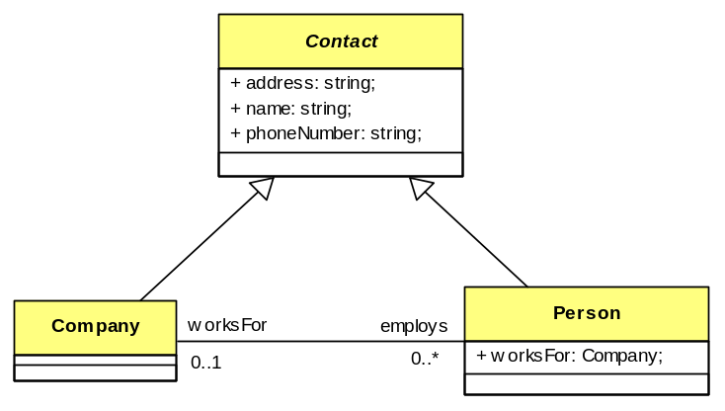

Lets start easy. This design is very basic and ignores requirements for complicated addresses and multiple phone numbers.

If you are not familiar with UML, the diagram shows three classes, represented by the rectangles. The class ‘Contact’ has its title displayed in italics to indicate it is an abstract class. The lines with the arrowheads indicate that both the ‘Company’ and ‘Person’ classes descend from the ‘Contact’ class.
The line between the ‘Company’ class and the ‘Person’ class indicates a relationship. Relationships contain a title, ‘Employment’, properties for each class, ‘worksFor’ and ‘employs’, as well as multiplicity specifiers, the ‘0..1’ and ‘0..*’. These will be explained in greater detail soon.

The model shows the following business rules:
- A Contact has a name, address and phone number.
- A Contact is either a Person or a Company.
- A Company employs zero or more Person.
- A Person works for zero or one Company.

If this model were implemented in a RDBS more than likely compromises to the design would have to be accepted, with the responsibility for the enforcement of the rules moved to the application logic. For example depending on how the data is ‘flattened’ the entities Person and Company may be represented in a single table requiring the relationship type restrictions being implemented in application code.

There is danger when moving from what is essentially an Object Oriented design to a flat relational database design. The Object oriented design clearly portrays real world entities and models valid business rules via relationships and care must be taken to preserve the intentions of the design. Often this can be difficult or impossible, resulting in the need for supplementary specifications. These document the business rules now required to be enforced in code.

“This is what BoldSoft terms the Executable Model Architecture (XMA)”
In reality this transformation results in an implementation that loses the intent of the original model and may even drop off important business rules if careful documentation processes aren’t followed. Indeed even if these rules are documented it is reliant on them being understood and implemented by the application programmer. As with all documentation it must also be manually maintained during the life cycle of the database.

The ultimate solution is to use a medium that accurately expresses the data model and is executable in the application. Because the documentation becomes the code, and vice-versa, business rules are maintained and enforced during the entire life cycle of the database application.

This is what BoldSoft terms the Executable Model Architecture (XMA) and is the foundation of the Bold for Delphi product.

Building the Application

Introduction
It’s time to start Delphi and ensure Bold for Delphi is installed. The following procedure should be complete enough for anyone that has used Delphi to follow easily. After each series of steps a description of what has been achieved is offered before moving on to the next steps.

Groundwork
To get started we need to setup a basic Delphi project with a data module.
- Select File|New Application from the Delphi menu.
- Save the Form unit as MainForm.pas and the project as ContactManager.dpr
- Add a new Data Module by selecting File/New and selecting Data Module from the New Items Dialog.
- Set the Data Modules name to BusinessModule.
- Save the DataModule as BusinessLayer.pas.

Models, Handles and Persistence
The basics for a Bold for Delphi application are adding our Model to the application and the chosen persistence layer. To prepare the application to accept a model, do the following:
- From the Bold Handles component tab add a BoldModel, BoldSystemTypeInfoHandle and BoldSystemHandle to the Data Module.
- Link the BoldModel property from BoldSystemTypeInfoHandle1 to BoldModel1.
- Link the BoldSystemTypeInfoHandle property from BoldSystemHandle1 to BoldSystemTypeInfoHandle1.
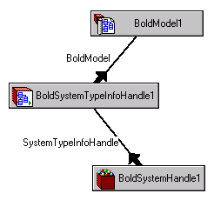

The BoldModel component will hold the model, that is the classes, relationships, constraints and types. Its role at design time is to hold the model and stores it as a string in the Delphi Form/Data module. At runtime it performs an intermediary transformation of the model into a format to be used by the BoldSystemTypeInfoHandle and the chosen persistence mechanism. The information stored in the BoldModel component can be thought of as metadata, in a similar way that you can query a database to provide table and field information. This component is generally used only at design time except for advanced operations not covered by this article.

The BoldSystemTypeInfoHandle component holds the runtime information needed by a BoldSystemHandle. The information is an efficient representation of the information in the UML-model, heavily optimized for speed. This component is generally not referenced directly in code, but rather acts as a source of information for other Bold for Delphi Components.

The BoldSystemHandle component is used to represent an entire system of domain elements, also known as an object-space. This component represents the available instances of objects in the model at runtime. This is the primary gateway between design time metadata and actual stored objects.

The components as they stand are fine for a system that doesn’t need to save data (persist) between sessions. However few applications have value without saving information between each use. To enable a fast path to running a Bold for Delphi Application we will add an XML persistence component to the data module
- From the Bold Persistence component tab add a BoldPersistenceHandleFileXML component to the data module.
- Link the BoldModel property to the BoldModel component.
- Link the PersistenceHandle property of BoldSystemHandle to the BoldPersistenceHandleFileXML component.

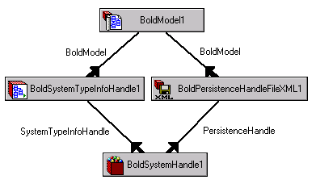
The BoldPersistenceHandleFileXML component allows the application to save and read objects from an XML file. This is a very handy component to use while you are still prototyping an architecture as is saves you from having to regenerate your database tables while still making significant changes to your model. Later on we will remove this component and use the BDE or Interbase components to allow use of a relational database. The design of the Bold for Delphi product allows us to do this without changing our application. This is called database independence. At that time we will also look closer at the SQL calls generated by Bold for Delphi, but for now we will forget this as it’s not critical for using Bold for Delphi.

Basic configuration Changes
Initially in this example application we will use the following property values, set these in the Delphi property editor:

Component: BoldSystemTypeInfoHandle1
Property: UseGeneratedCode
Value: False
Later on we will enable this and work directly with the model using Object Pascal, but initially this is not required.

Component: BoldPersistenceHandleFileXML1
Property: FileName
Value: Data.XML
To begin with the XML file is hard coded, this of course could be set using code at runtime in a real application.

Component: BoldSystemHandle1
Property: Active
Value: True
This property results in the Bold for Delphi system opening the XML file and being ready for immediate use on application startup.

Building the Model
The next step is to build our model. Bold for Delphi comes with an inbuilt non-graphical UML modeling tool. It is accessed by double clicking on the BoldModel component.

Bold for Delphi UML Model Editor
The Bold for Delphi UML model editor (Figure 1) contains the application model information, data type information, and relational database mapping information.

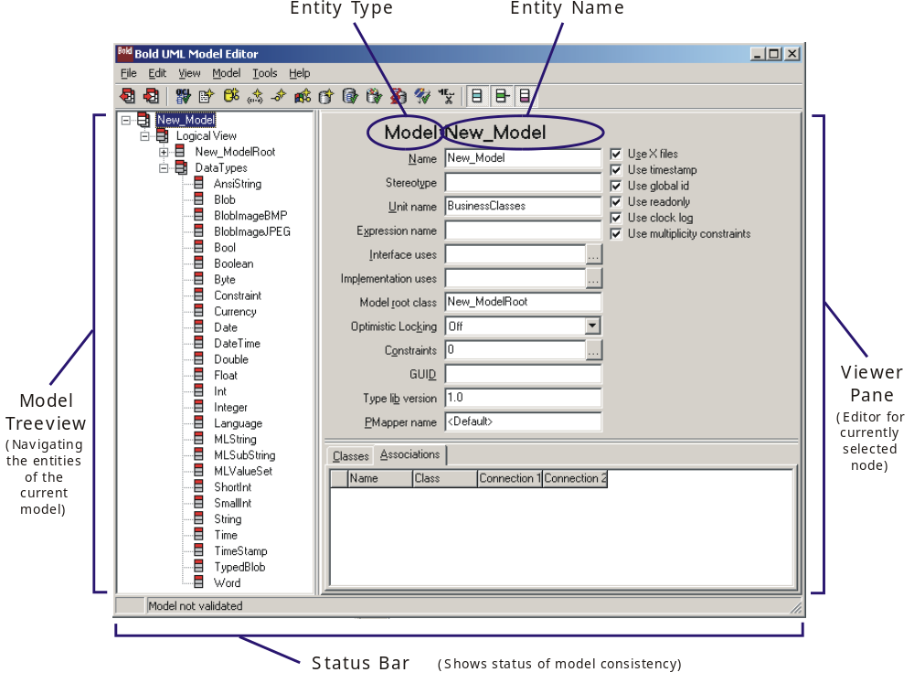
Figure 1: Model Editor

Model Entities
The modeler supports the following entity types:
- Model: Collection of all entities representing the problem domain.
- Package: A collection of entities representing a subset of the entire model, useful for reducing complexity by breaking a model into a collection of smaller models.
- Class: An object, similar in concept to Delphi classes (Delphi classes can be generated for an UML class) but can contain information and relationships not directly available to object pascal classes. Fortunately Bold for Delphi wraps this extra functionality into object pascal classes by using association classes and special list classes that remove this complexity for the pascal programmer.
- Attribute: This is the equivalent to Delphi properties, however in Bold for Delphi these can be derived using an OCL expression or have initialization values set directly in the model. In a lot of circumstances this removes the need to create getter and setter methods like in traditional object pascal programming.
- Operation: This is the equivalent to a Delphi method (Function/Procedure).
- Association: Associations represent the relationships between classes. Depending on the type of relationship an association maybe represented by a class itself, this allows for Operations & Attributes to be part of an association between classes. Associations in Bold for Delphi are much more powerful than properties of a class type in Delphi objects, again the complexity of mapping this extra functionality in Delphi classes is performed by Bold for Delphi.
- Role: A Role represents the connection of an Association to a class.
- Data Type: Represents the different Data Types supported within the model. This can be extended to include custom Data Types.

Figure 2 shows the how different entities are represented in the Model Editor. These will be explained in more detail as we build our model.

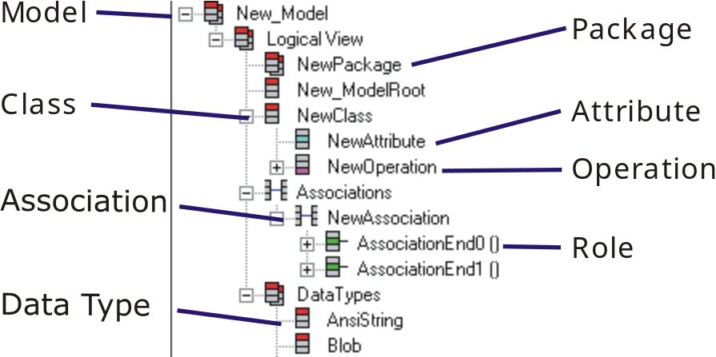
Figure 2: Model Entity Types

The Model menu in the editor will change depending on the entity selected, these options are also available from the right-click context menu in the Model Treeview. For example, to add a Class you need to have a Model entity or Package entity selected, as these are the only entities that can contain a Class.

Most of the options are fine ‘out of the box’ and this is how we will start with Bold for Delphi.

In Figure 1 The root node New_Model is selected and the viewer pane on the right shows the global options for our model, to begin with the most important are:

- Name: The name for the model.

- Unit name: The pascal unit that will be generated to hold our classes if we choose to generate code. Generating code is optional. However if you do generate code this is the default unit that the code is placed. This can be overridden for each class if desired.

- Model root class: This should be set to the name of the class in our model that is the root of all other classes.

Change the Name property to BusinessClasses. This is clearer than New_Model.

The default super class for all business objects is the New_ModelRoot class. Change the Name of this class to BusinessClassesRoot, this is clearer and represents a valid Delphi class name. When you change the root class in a model ensure you update the model’s Model root class property to match. In this case we need to set it to BusinessClassesRoot.

Adding our Business Objects
With the newly named node BusinessClasses highlighted, select the New Class option from the Model menu. This option is only available if a model entity is selected in the treeview.

Change the name of the newly created class to Contact and then repeat creating a new class for both Company and Person. Don’t forget you will need to select the BusinesClasses model each time for the New Class menu item to be visible. (Optionally you can use the right-click context menu in the treeview)

Set the following options for the new classes:
- Contact: Set the abstract checkbox as checked.
- Person: Set the SuperClass combo box to Contact.
- Company: Set the SuperClass combo box to Contact.

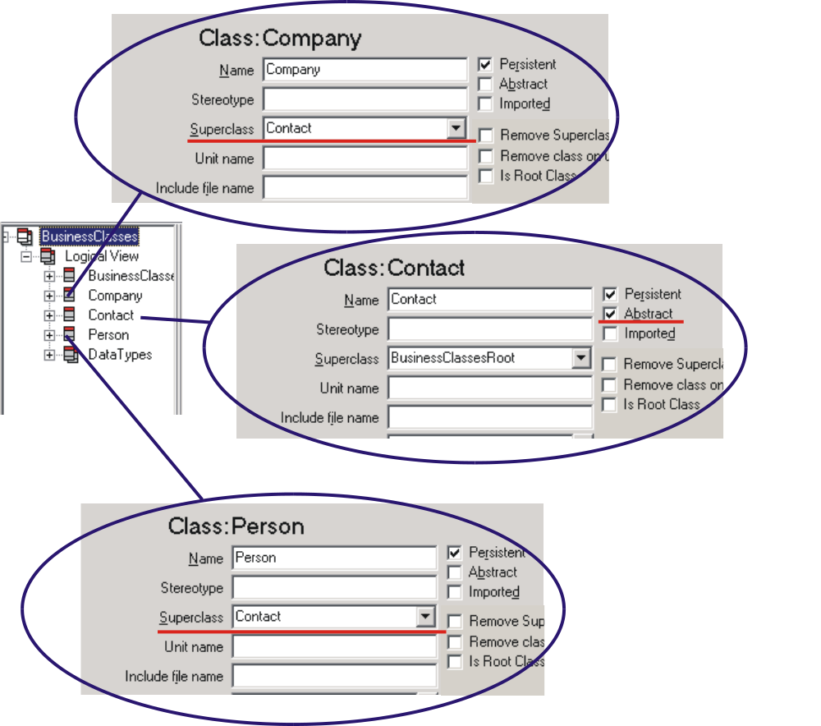
Figure 3: Basic Classes

Figure 3 shows the changes applied in the model editor. We have now created our basic classes, but more importantly we have enforced some of the business rules mentioned earlier.

By marking the Contact class as abstract, Bold for Delphi will not allow you to create instances of this class. Because both Company and Person have the superclass of Contact, they will inherit any attributes and operations of Contact. Importantly any instance of Company or Person can be treated as if they are a class of Contact, making it possible, where required to treat these classes the same.

Adding Attributes
Select the Contact class in the model editor treeview. Using the Model menu again you’ll notice the options have changed to suit a class entity. Select Add Attribute three times and name them name, address and phoneNumber respectively. You will notice the capitalization I have used is a bit different. This is an UML convention, although not enforced in the model, it is a good habit to follow. When writing OCL expressions the UML capitalization style is important and errors will result form poorly formed expressions.

Check each attribute as Persistent; this is required for Bold for Delphi to save the values to the database. Leave the default type as String and leave the default length of 255. Strings are the only type that recognize the length parameter.

Because we have added these attributes to the Contact class and both Company and Person descend from Contact, they will both inherit the attributes name, address and phoneNumber.

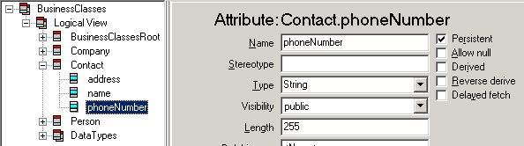
Figure 4: Basic Attributes

Adding the Association
With BusinessClasses highlighted, select the New Association option from the Model menu. This option is only available if a model entity is selected in the treeview.

Name the new association Employment and name each of the association ends (Roles) worksFor and employs. For each of the roles set the following parameters:
- worksFor: Select Company as the class for this role.
- employs: Select Person as the class for this role. Unselect the Embed checkbox and choose 0..* as the multiplicity for this role. You will see on changing the multiplicity that Bold for Delphi automatically checks the Multi checkbox.

These changes are shown in Figure 5.
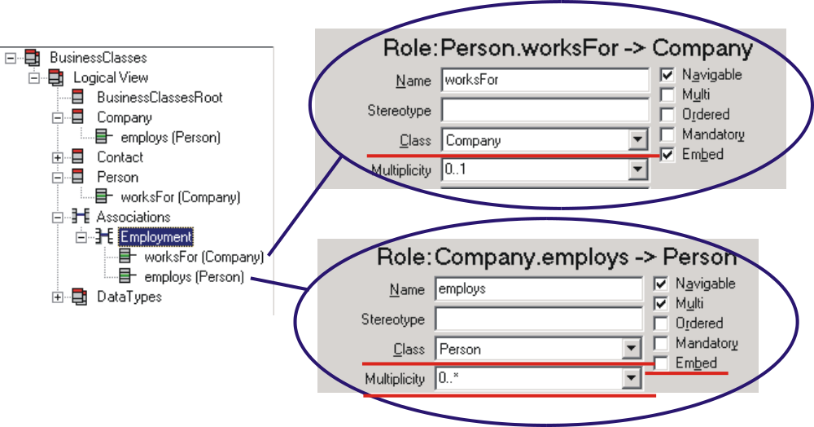
Figure 5: Employment Association

This is all that is required to complete the modeling of our original design. Using Bold for Delphi we have accurately represented all shown business rules simply and without complicating the design due to language limitations.

Before we leave the model editor lets have a look at multiplicity and embed options a little further.

Multiplicity is the measure of the number of ‘connections’ at the association end point. There are four basic options:
- 0..1: Zero or one connection.
- 1..1: Must have one and only one connection.
- 0..*: Zero or many connections.
- 1..*: One or many connections.

It is also possible to use n-cardinality relationships like 4..7 or 2..2. Embedding is the process of using a field in association end’s class to store the associated objects reference, for now all you need to know is that:
- To be able to embed an association end it must be of single cardinality. E.g. 0..1 or 1..1.
- If both associations can have two or more connections (i.e. a multi-multi association) then a link class must be used to hold the association. This is also true if you decide not to embed both ends of a single cardinality association.
- It is not good practice to embed both ends of an association.

This topic will be revisited in more detail later.

Adding a User Interface

Simple Main Form
To get the application up and running as soon as possible we will build a simple main form allowing us to edit the business objects. This will allow for testing of the design and a demonstration of a few Bold for Delphi features.

To the MainForm.pas unit add BoldAFPDefault and BusinessLayer to the uses clause. The BoldAFPDefault unit allows Bold for Delphi to automatically generate editor forms for the business objects that can be launched automatically from Bold-aware controls. The BusinessLayer unit allows the Bold for Delphi Controls to see the model on the data module.

From the Bold Handles component palette add 3 BoldListHandle components to the form. From the Bold Controls component palette add 3 BoldNavigator components and 3 BoldGrid components. Also add 3 standard Delphi Label components to help keep everything in order.

Use the following layout to position the controls. The caption of each label has been set to describe the control:

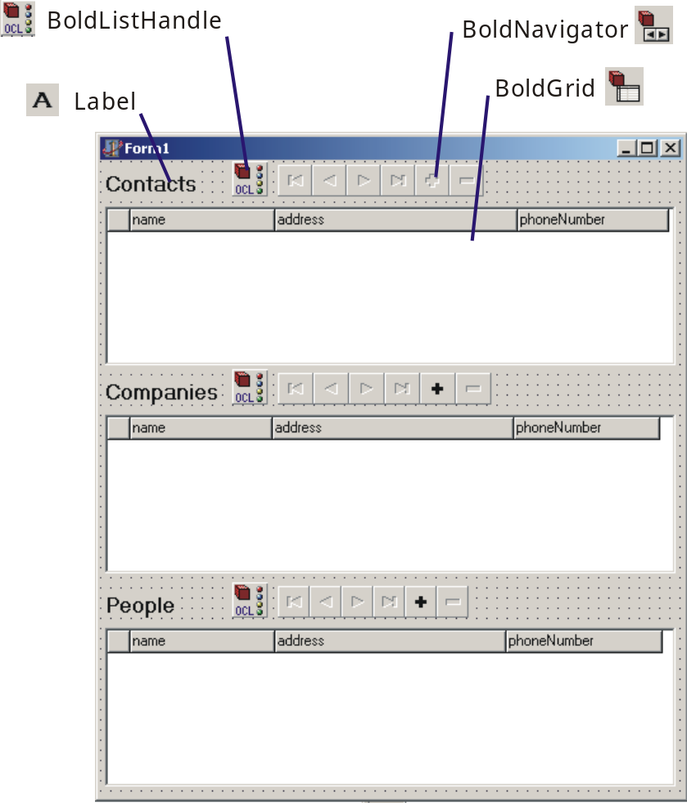

For each group of controls set the following properties:

Contacts

BoldListHandle
Name: ContactList
RootHandle: BusinessModule.BoldSystemHandle1
Expression: Contact.allInstances

BoldNavigator
Name: ContactNavigator
BoldHandle: ContactList

BoldGrid
Name: ContactGrid
BoldHandle: ContactList

After setting the BoldHandle property, right-click on the grid and select Create Default Columns from the context menu.

Companies

BoldListHandle
Name: CompanyList
RootHandle: BusinessModule.BoldSystemHandle1
Expression: Company.allInstances

BoldNavigator
Name: CompanyNavigator
BoldHandle: CompanyList

BoldGrid
Name: CompanyGrid
BoldHandle: CompanyList

After setting the BoldHandle property, right-click on the grid and select Create Default Columns from the context menu.

People

BoldListHandle
Name: PersonList
RootHandle: BusinessModule.BoldSystemHandle1
Expression: Person.allInstances

BoldNavigator
Name: PersonNavigator
BoldHandle: PersonList

BoldGrid
Name: PersonGrid
BoldHandle: PersonList

After setting the BoldHandle property, right-click on the grid and select Create Default Columns from the context menu.

Almost ready to run, add the following event handler for the form’s OnClose event:

procedure TForm1.FormClose(Sender: TObject; var Action: TCloseAction);
begin
BusinessModule.BoldSystemHandle1.System.UpdateDatabase;
end;

This ensures that any information entered at runtime will be saved to the XML file.

Running The Application

Entering Test Data
Run the application and enter some companies and people. Figure 6 shows the application at runtime with some sample data.

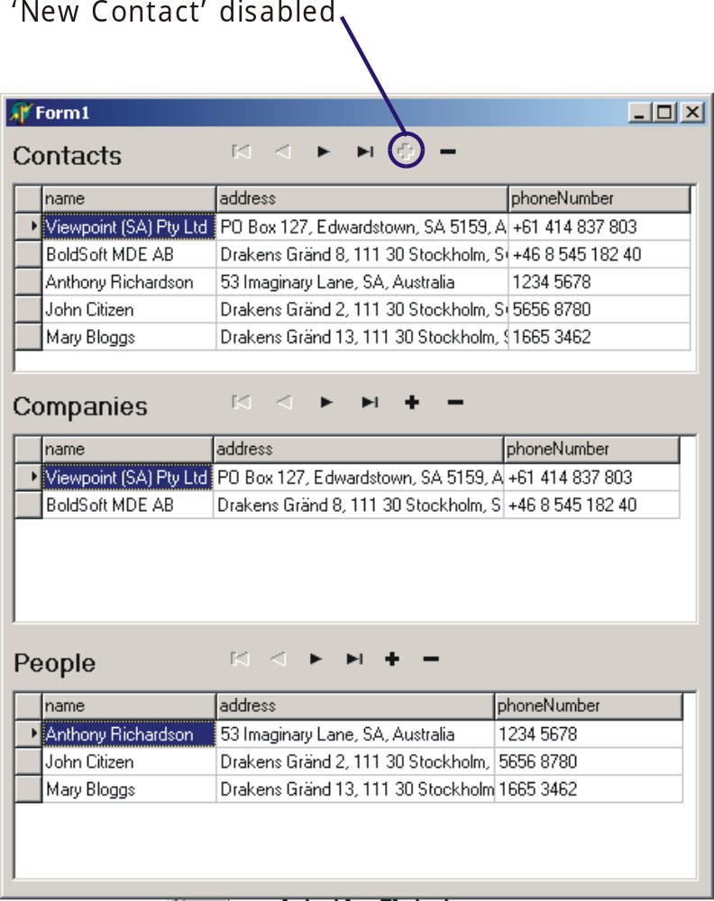
Figure 6: Basic Application at Runtime
It is important to spend sometime discussing what the features of this basic screen are in comparison to traditional Delphi database applications. The distinctions are important because the Bold for Delphi data-aware solution overcomes many shortcomings of traditional Delphi data-aware controls.

Delphi Data-aware and Bold-aware Comparison
There are some important behavioral differences between Delphi data-aware and Bold-aware components. The key to the difference is meta-data, that is data about data. This may be confusing at first but it’s the meta-data in the model driven Bold for Delphi approach that allows for the more sophisticated controls in a Bold-aware application.

A simple example is the Contacts Navigator, it recognizes that Contacts is an abstract class and cannot be created directly. Therefore it disables the ‘+’ append button (As indicated in Figure 6). Although only a simple example, the benefits of controls that understand the context of the data they are presenting is extremely valuable and assists in writing correct code.

Another important distinction between Bold-aware and standard data-aware solutions is the synchronization of data between grids. In a traditional data-aware application you would need to resort to using:

Multiple Queries
Three grids each linked to a query containing the SQL statement required to retrieve the desired data.
This solution is relatively easy to implement but suffers the problem of no synchronization between each grid. Updating each grid requires re-running the queries. This can be problematic and requires careful consideration with the status of each query (e.g. Is it currently in edit mode?).

“There are some important behavioral differences between Delphi Data-aware and Bold-aware components”

Filtered Grids
By using a single query and purchasing a third-party grid with inbuilt filtering it may be possible to replicate the functionality without resorting to desynchronizing queries. However depending on the nature of the SQL statement it may not be updateable, leaving you with a read-only solution.
Another, not so obvious, limitation of this method is that a single record only can be the ‘active’ or ‘current’ record. Depending on the third-party grid supplied this can cause problems.

In Figure 6 that each grid has a separate object selected and entering or changing data the changes are automatically propagated to all other controls. Bold for Delphi supports various methods to ensure this behavior is supported between applications running on different computers across the network. A change in an object on one computer can automatically be reflected and updated on every other computer on the network.

More examples of the differences will eventuate as the series progresses.

Default Object Editor Forms
With the application running double click the index marker on the left hand side of a grid. An object editor dialog will be created, customized to the object type. These editors are enabled by the inclusion of the BoldAFPDefault unit anywhere in the application.

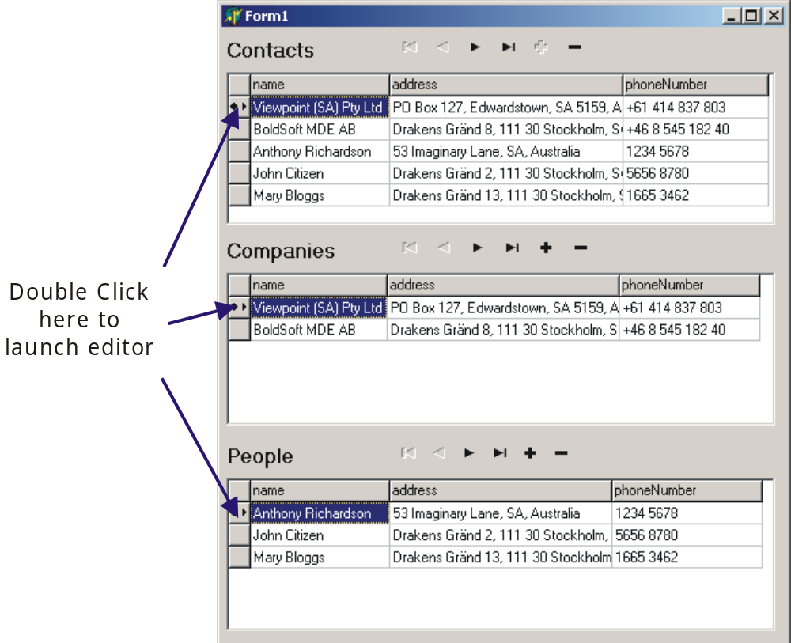
Figure 7: Editor Launch Points

In Figure 7 the selection column of the grid displays a small circle to indicate that the object in that row is selected and a small arrowhead to indicate that the object for that row is the currently active object. It is possible to multiple select objects (rows) in the grid by ctrl+clicking each object. It is also possible to select all objects in the grid by clicking the top left cell in the column header.
The default object editors aren’t much to look at but they are fully functional and support all relationships. You may have noticed that our application was incapable of displaying and editing the relationships between companies and people. The built in editors support these relationships.

Using the Drag Points on the editors (refer Figure 8) you can establish the links by dragging a Person into the employs grid of the Company object.

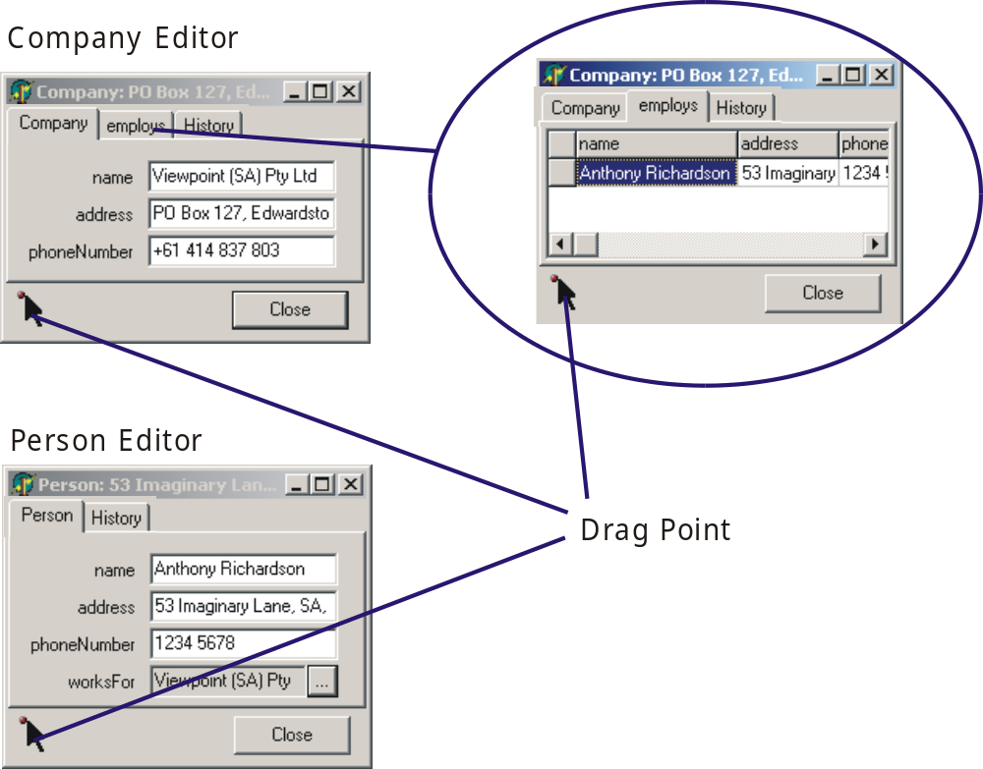
Figure 8: Object Runtime Editors

It is also important to note the other differences with these editors. They are not linked to the grid so you can have multiple editors open and navigate the grid without problem. It is problematic in a traditional data-aware application to do this as when the cursor changes the edit controls change.

The ‘History’ tab is used if you have purchased the optional Object Versioning Extension. With this powerful add-on Bold for Delphi will record the changes in your objects over time. By marking a class as versioned in the Bold for Delphi UML editor this recording is enabled. By using OCL or direct method calls of your domain objects, you can request an instance of your objects as they were at any point in time. Bold for Delphi even versions the relationships so you can navigate your model as it was at that time.

Summary
This article has demonstrated the basics a building a Bold for Delphi Model driven application. It has shown the key concepts of a simple Bold for Delphi Application and discussed briefly the usage of these concepts. A basic comparison to traditional database programming was supplied where possible.

As much as this article has introduced the basics, many questions remain and only a small part of the Bold for Delphi product has been shown.

Future
Future articles will explore some of the existing concepts in more depth and venture into the specifics of using various Bold for Delphi constructs to solve the common challenges faced in application development.

Appendix A: Source Code

Instructions
In this section you will find the source code for the project used in this article. The article clear shows how to build this project step by step, however you may choose to use this source code. Maybe you prefer to run the program before reading the article or you are having trouble understanding the article and wish to look at the source.

Whatever you reason to create the source files is simple. All files can be created using an standard ASCII text editor like notepad.exe. Cut and paste the contents of each file and save the file using the correct name and extension.

The format of the listing is:

Start listing Filename
Contents of file
In between the lines.
End listing Filename

All files need to placed in the same directory, then simply load the DPR file into Delphi and compile.

ContactManager.dpr
Start listing ContactManager.dpr
program ContactManager;

uses
Forms,
MainForm in 'MainForm.pas' {Form1},
BusinessLayer in 'BusinessLayer.pas' {BusinessModule: TDataModule};

{$R *.RES}

begin
Application.Initialize;
Application.CreateForm(TBusinessModule, BusinessModule);
Application.CreateForm(TForm1, Form1);
Application.Run;
end.
End listing ContactManager.dpr

MainForm.pas
Start listing MainForm.pas
unit MainForm;

interface

uses
Windows, Messages, SysUtils, Classes, Graphics, Controls, Forms, Dialogs,
BusinessLayer, ExtCtrls, BoldNavigator, Grids, BoldGrid,
BoldSubscription, BoldHandles, BoldRootedHandles, BoldAbstractListHandle,
BoldCursorHandle, BoldListHandle, BoldAFPDefault, StdCtrls,
BoldNavigatorDefs;

type
TForm1 = class(TForm)
ContactGrid: TBoldGrid;
ContactNavigator: TBoldNavigator;
CompanyGrid: TBoldGrid;
PersonGrid: TBoldGrid;
ContactList: TBoldListHandle;
CompanyList: TBoldListHandle;
PersonList: TBoldListHandle;
CompanyNavigator: TBoldNavigator;
PersonNavigator: TBoldNavigator;
Label1: TLabel;
Label2: TLabel;
Label3: TLabel;
procedure FormClose(Sender: TObject; var Action: TCloseAction);
private
{ Private declarations }
public
{ Public declarations }
end;

var
Form1: TForm1;

implementation

{$R *.DFM}

procedure TForm1.FormClose(Sender: TObject; var Action: TCloseAction);
begin
BusinessModule.BoldSystemHandle1.System.UpdateDatabase;
end;

end.
End listing of MainForm.pas

MainForm.dfm
Start listing MainForm.dfm
object Form1: TForm1
Left = 368
Top = 199
Width = 467
Height = 528
Caption = 'Form1'
Color = clBtnFace
Font.Charset = DEFAULT_CHARSET
Font.Color = clWindowText
Font.Height = -11
Font.Name = 'MS Sans Serif'
Font.Style = []
OldCreateOrder = False
OnClose = FormClose
PixelsPerInch = 96
TextHeight = 13
object Label1: TLabel
Left = 4
Top = 8
Width = 73
Height = 20
Caption = 'Contacts'
Font.Charset = DEFAULT_CHARSET
Font.Color = clWindowText
Font.Height = -16
Font.Name = 'MS Sans Serif'
Font.Style = [fsBold]
ParentFont = False
end
object Label2: TLabel
Left = 4
Top = 172
Width = 90
Height = 20
Caption = 'Companies'
Font.Charset = DEFAULT_CHARSET
Font.Color = clWindowText
Font.Height = -16
Font.Name = 'MS Sans Serif'
Font.Style = [fsBold]
ParentFont = False
end
object Label3: TLabel
Left = 4
Top = 340
Width = 56
Height = 20
Caption = 'People'
Font.Charset = DEFAULT_CHARSET
Font.Color = clWindowText
Font.Height = -16
Font.Name = 'MS Sans Serif'
Font.Style = [fsBold]
ParentFont = False
end
object ContactGrid: TBoldGrid
Left = 4
Top = 36
Width = 449
Height = 125
AddNewAtEnd = False
BoldAutoColumns = False
BoldShowConstraints = False
BoldHandle = ContactList
BoldProperties.NilElementMode = neNone
Columns = <
item
Color = clBtnFace
Font.Charset = DEFAULT_CHARSET
Font.Color = clWindowText
Font.Height = -11
Font.Name = 'MS Sans Serif'
Font.Style = []
end
item
BoldProperties.Expression = 'name'
Font.Charset = DEFAULT_CHARSET
Font.Color = clWindowText
Font.Height = -11
Font.Name = 'MS Sans Serif'
Font.Style = []
end
item
BoldProperties.Expression = 'address'
Font.Charset = DEFAULT_CHARSET
Font.Color = clWindowText
Font.Height = -11
Font.Name = 'MS Sans Serif'
Font.Style = []
end
item
BoldProperties.Expression = 'phoneNumber'
Font.Charset = DEFAULT_CHARSET
Font.Color = clWindowText
Font.Height = -11
Font.Name = 'MS Sans Serif'
Font.Style = []
end>
DefaultRowHeight = 17
EnableColAdjust = False
TabOrder = 0
TitleFont.Charset = DEFAULT_CHARSET
TitleFont.Color = clWindowText
TitleFont.Height = -11
TitleFont.Name = 'MS Sans Serif'
TitleFont.Style = []
ColWidths = (
17
113
190
118)
end
object ContactNavigator: TBoldNavigator
Left = 140
Top = 3
Width = 162
Height = 25
BoldHandle = ContactList
Flat = True
TabOrder = 1
ImageIndices.nbFirst = -1
ImageIndices.nbPrior = -1
ImageIndices.nbNext = -1
ImageIndices.nbLast = -1
ImageIndices.nbInsert = -1
ImageIndices.nbDelete = -1
ImageIndices.nbMoveUp = -1
ImageIndices.nbMoveDown = -1
DeleteQuestion = 'Delete %0:s?'
UnlinkQuestion = 'Unlink "%1:s" from "%2:s"?'
RemoveQuestion = 'Remove "%1:s" from the list?'
end
object CompanyGrid: TBoldGrid
Left = 4
Top = 200
Width = 449
Height = 125
AddNewAtEnd = False
BoldAutoColumns = False
BoldShowConstraints = False
BoldHandle = CompanyList
BoldProperties.NilElementMode = neNone
Columns = <
item
Color = clBtnFace
Font.Charset = DEFAULT_CHARSET
Font.Color = clWindowText
Font.Height = -11
Font.Name = 'MS Sans Serif'
Font.Style = []
end
item
BoldProperties.Expression = 'name'
Font.Charset = DEFAULT_CHARSET
Font.Color = clWindowText
Font.Height = -11
Font.Name = 'MS Sans Serif'
Font.Style = []
end
item
BoldProperties.Expression = 'address'
Font.Charset = DEFAULT_CHARSET
Font.Color = clWindowText
Font.Height = -11
Font.Name = 'MS Sans Serif'
Font.Style = []
end
item
BoldProperties.Expression = 'phoneNumber'
Font.Charset = DEFAULT_CHARSET
Font.Color = clWindowText
Font.Height = -11
Font.Name = 'MS Sans Serif'
Font.Style = []
end>
DefaultRowHeight = 17
EnableColAdjust = False
TabOrder = 2
TitleFont.Charset = DEFAULT_CHARSET
TitleFont.Color = clWindowText
TitleFont.Height = -11
TitleFont.Name = 'MS Sans Serif'
TitleFont.Style = []
ColWidths = (
17
111
189
114)
end
object PersonGrid: TBoldGrid
Left = 4
Top = 368
Width = 449
Height = 125
AddNewAtEnd = False
BoldAutoColumns = False
BoldShowConstraints = False
BoldHandle = PersonList
BoldProperties.NilElementMode = neNone
Columns = <
item
Color = clBtnFace
Font.Charset = DEFAULT_CHARSET
Font.Color = clWindowText
Font.Height = -11
Font.Name = 'MS Sans Serif'
Font.Style = []
end
item
BoldProperties.Expression = 'name'
Font.Charset = DEFAULT_CHARSET
Font.Color = clWindowText
Font.Height = -11
Font.Name = 'MS Sans Serif'
Font.Style = []
end
item
BoldProperties.Expression = 'address'
Font.Charset = DEFAULT_CHARSET
Font.Color = clWindowText
Font.Height = -11
Font.Name = 'MS Sans Serif'
Font.Style = []
end
item
BoldProperties.Expression = 'phoneNumber'
Font.Charset = DEFAULT_CHARSET
Font.Color = clWindowText
Font.Height = -11
Font.Name = 'MS Sans Serif'
Font.Style = []
end>
DefaultRowHeight = 17
EnableColAdjust = False
TabOrder = 3
TitleFont.Charset = DEFAULT_CHARSET
TitleFont.Color = clWindowText
TitleFont.Height = -11
TitleFont.Name = 'MS Sans Serif'
TitleFont.Style = []
ColWidths = (
17
113
181
122)
end
object CompanyNavigator: TBoldNavigator
Left = 140
Top = 167
Width = 168
Height = 25
BoldHandle = CompanyList
Flat = True
TabOrder = 4
ImageIndices.nbFirst = -1
ImageIndices.nbPrior = -1
ImageIndices.nbNext = -1
ImageIndices.nbLast = -1
ImageIndices.nbInsert = -1
ImageIndices.nbDelete = -1
ImageIndices.nbMoveUp = -1
ImageIndices.nbMoveDown = -1
DeleteQuestion = 'Delete %0:s?'
UnlinkQuestion = 'Unlink "%1:s" from "%2:s"?'
RemoveQuestion = 'Remove "%1:s" from the list?'
end
object PersonNavigator: TBoldNavigator
Left = 140
Top = 335
Width = 150
Height = 25
BoldHandle = PersonList
Flat = True
TabOrder = 5
ImageIndices.nbFirst = -1
ImageIndices.nbPrior = -1
ImageIndices.nbNext = -1
ImageIndices.nbLast = -1
ImageIndices.nbInsert = -1
ImageIndices.nbDelete = -1
ImageIndices.nbMoveUp = -1
ImageIndices.nbMoveDown = -1
DeleteQuestion = 'Delete %0:s?'
UnlinkQuestion = 'Unlink "%1:s" from "%2:s"?'
RemoveQuestion = 'Remove "%1:s" from the list?'
end
object ContactList: TBoldListHandle
RootHandle = BusinessModule.BoldSystemHandle1
Expression = 'Contact.allInstances'
Left = 104
end
object CompanyList: TBoldListHandle
RootHandle = BusinessModule.BoldSystemHandle1
Expression = 'Company.allInstances'
Left = 104
Top = 164
end
object PersonList: TBoldListHandle
RootHandle = BusinessModule.BoldSystemHandle1
Expression = 'Person.allInstances'
Left = 104
Top = 332
end
end
End listing MainForm.dfm

BusinessLayer.pas
Start listing BusinessLayer.pas
unit BusinessLayer;

interface

uses
Windows, Messages, SysUtils, Classes, Graphics, Controls, Forms, Dialogs,
BoldAbstractModel, BoldModel, BoldHandles, BoldSubscription,
BoldSystemHandle, BoldHandle, BoldPersistenceHandle,
BoldPersistenceHandleFile, BoldPersistenceHandleFileXML,
BoldRootedHandles, BoldAbstractListHandle, BoldCursorHandle,
BoldListHandle;

type
TBusinessModule = class(TDataModule)
BoldSystemHandle1: TBoldSystemHandle;
BoldSystemTypeInfoHandle1: TBoldSystemTypeInfoHandle;
BoldModel1: TBoldModel;
BoldPersistenceHandleFileXML1: TBoldPersistenceHandleFileXML;
private
{ Private declarations }
public
{ Public declarations }
end;

var
BusinessModule: TBusinessModule;

implementation

{$R *.DFM}

end.
End Listing BusinessLayer.pas

BusinessLayer.dfm
Start listing BusinessLayer.dfm
object BusinessModule: TBusinessModule
OldCreateOrder = False
Left = 365
Top = 223
Height = 438
Width = 686
object BoldSystemHandle1: TBoldSystemHandle
IsDefault = True
SystemTypeInfoHandle = BoldSystemTypeInfoHandle1
Active = True
PersistenceHandle = BoldPersistenceHandleFileXML1
Left = 68
Top = 128
end
object BoldSystemTypeInfoHandle1: TBoldSystemTypeInfoHandle
BoldModel = BoldModel1
UseGeneratedCode = False
Left = 68
Top = 68
end
object BoldModel1: TBoldModel
UMLModelMode = ummNone
Boldify.EnforceDefaultUMLCase = False
Boldify.DefaultNavigableMultiplicity = '0..1'
Boldify.DefaultNonNavigableMultiplicity = '0..*'
Left = 68
Top = 12
Model = (
'VERSION 19'
'(Model'
#9'"BusinessClasses"'
#9'"BusinessClassesRoot"'
#9'""'
#9'""'

#9'"_Boldify.boldified=True,_BoldInternal.flattened=True,_BoldInte' +
'rnal.ModelErrors=,Bold.DelphiName=<Name>,Bold.RootClass=Business' +
'ClassesRoot"'
#9'(Classes'
#9#9'(Class'
#9#9#9'"BusinessClassesRoot"'
#9#9#9'"<NONE>"'
#9#9#9'TRUE'
#9#9#9'FALSE'
#9#9#9'""'
#9#9#9'""'
#9#9#9'"persistence=persistent"'
#9#9#9'(Attributes'
#9#9#9')'
#9#9#9'(Methods'
#9#9#9')'
#9#9')'
#9#9'(Class'
#9#9#9'"Contact"'
#9#9#9'"BusinessClassesRoot"'
#9#9#9'TRUE'
#9#9#9'TRUE'
#9#9#9'""'
#9#9#9'""'
#9#9#9'"persistence=persistent"'
#9#9#9'(Attributes'
#9#9#9#9'(Attribute'
#9#9#9#9#9'"name"'
#9#9#9#9#9'"String"'
#9#9#9#9#9'FALSE'
#9#9#9#9#9'""'
#9#9#9#9#9'""'
#9#9#9#9#9'2'
#9#9#9#9#9'""'
#9#9#9#9#9'"persistence=persistent"'
#9#9#9#9')'
#9#9#9#9'(Attribute'
#9#9#9#9#9'"address"'
#9#9#9#9#9'"String"'
#9#9#9#9#9'FALSE'
#9#9#9#9#9'""'
#9#9#9#9#9'""'
#9#9#9#9#9'2'
#9#9#9#9#9'""'
#9#9#9#9#9'"persistence=persistent"'
#9#9#9#9')'
#9#9#9#9'(Attribute'
#9#9#9#9#9'"phoneNumber"'
#9#9#9#9#9'"String"'
#9#9#9#9#9'FALSE'
#9#9#9#9#9'""'
#9#9#9#9#9'""'
#9#9#9#9#9'2'
#9#9#9#9#9'""'
#9#9#9#9#9'"persistence=persistent"'
#9#9#9#9')'
#9#9#9')'
#9#9#9'(Methods'
#9#9#9')'
#9#9')'
#9#9'(Class'
#9#9#9'"Person"'
#9#9#9'"Contact"'
#9#9#9'TRUE'
#9#9#9'FALSE'
#9#9#9'""'
#9#9#9'""'
#9#9#9'"persistence=persistent"'
#9#9#9'(Attributes'
#9#9#9')'
#9#9#9'(Methods'
#9#9#9')'
#9#9')'
#9#9'(Class'
#9#9#9'"Company"'
#9#9#9'"Contact"'
#9#9#9'TRUE'
#9#9#9'FALSE'
#9#9#9'""'
#9#9#9'""'
#9#9#9'"persistence=persistent"'
#9#9#9'(Attributes'
#9#9#9')'
#9#9#9'(Methods'
#9#9#9')'
#9#9')'
#9')'
#9'(Associations'
#9#9'(Association'
#9#9#9'"Employment"'
#9#9#9'"<NONE>"'
#9#9#9'""'
#9#9#9'""'
#9#9#9'"persistence=persistent,Bold.DelphiName=<Name>"'
#9#9#9'FALSE'
#9#9#9'(Roles'
#9#9#9#9'(Role'
#9#9#9#9#9'"worksFor"'
#9#9#9#9#9'TRUE'
#9#9#9#9#9'FALSE'
#9#9#9#9#9'"Person"'
#9#9#9#9#9'""'
#9#9#9#9#9'"0..1"'
#9#9#9#9#9'""'
#9#9#9#9#9'0'
#9#9#9#9#9'2'
#9#9#9#9#9'0'
#9#9#9#9#9'""'
#9#9#9#9#9'(Qualifiers'
#9#9#9#9#9')'
#9#9#9#9')'
#9#9#9#9'(Role'
#9#9#9#9#9'"employs"'
#9#9#9#9#9'TRUE'
#9#9#9#9#9'FALSE'
#9#9#9#9#9'"Company"'
#9#9#9#9#9'""'
#9#9#9#9#9'"0..*"'
#9#9#9#9#9'""'
#9#9#9#9#9'0'
#9#9#9#9#9'2'
#9#9#9#9#9'0'
#9#9#9#9#9'"Bold.Embed=False"'
#9#9#9#9#9'(Qualifiers'
#9#9#9#9#9')'
#9#9#9#9')'
#9#9#9')'
#9#9')'
#9')'
')')
end
object BoldPersistenceHandleFileXML1: TBoldPersistenceHandleFileXML
FileName = 'data.xml'
CacheData = False
BoldModel = BoldModel1
Left = 68
Top = 184
end
end
End Listing BusinessLayer.dfm

